FLOWSMART LEAK DETECTION SYSTEM

BONFACE MUNENE
SCT221-0401/2022

A project submitted to the Department of Information Technology in the School of Computing and Information Technology in partial fulfillment of the requirement for the award of the degree of Information Technology at Jomo Kenyatta University of Agriculture and Technology

MAY, 2025

DECLARATION
I declare that this project is my original work and has not been presented for a degree or other award in this or any other University.

Sign ……………………… Date …………………………
Bonface Munene
SCT221-0401/2022

I declare that this project has been submitted for examination with my approval as University Supervisor.

Sign ………………………. Date ……………………………

LIST OF FIGURES
Figure 1: Scrum Methodology 8
Figure 2: Scrum methodology 14
Figure 3: What challenges do you face in detecting and preventing water leaks? 20
Figure 4: What are the main challenges you face when dealing with water leaks? 21
Figure 5: What solutions do you believe would be most effective in reducing water leakage 21
Figure 6: Use case Diagram 24
Figure 7: Sequence Diagram 25
Figure 8: Class Diagram 26
Figure 9: ER Diagram 27
Figure 10: Sign-up page 29
Figure 11: Login page 30
Figure 12 :Analytic outcomes 30

TABLE OF CONTENTS
DECLARATION ii
ABSTRACT vii
CHAPTER ONE 1
INTRODUCTION 1
1.1 Introduction 1
1.2 Problem Statement 1
1.3 Proposed Solution 2
1.4 Objectives 2
1.4.1 Main Objective 2
1.4.2 Specific Objectives 3
1.5 Research Questions 3
1.6 Justification 3
1.7 Scope 5
1.8 Proposed Research and System Methodology 6
1.9 Research Methodology 6
1.10 System Methodology 7
CHAPTER TWO 9
LITERATURE REVIEW 9
2.1 Introduction 9
2.2. Global Perspective 9
2.2.1 Smart Leak Prevention Systems and IoT Integration 9
2.3 Regional Perspective 10
2.4 Local Perspective 11
2.5 Conclusion: Project on Water Management Leak Prevention System 12
CHAPTER THREE 13
SYSTEM ANALYSIS AND DESIGN 13
3.1 Introduction 13
3.2 System Development Methodology 13
3.3 Feasibility Study 15
3.3.1 Technical Feasibility 15
3.3.2 Operational Feasibility 15
3.3.3 Economic Feasibility 15
Initial Costs (Reduced): 16
Ongoing Annual Costs: 16
Annual Savings & Benefits: 16
ROI Calculation (Over 3 Years): 17
3.3.4 Legal and Ethical Feasibility 17
3.4 Requirements Elicitation 17
3.4.1 Data Collection Methods 18
3.4.2 Sampling Techniques 18
3.4.3 Sample Size Determination 19
3.4.4 Data Relevance 19
3.4.5 Data Analysis 20
3.5 System Specification 21
3.5.1 Functional Requirements 22
3.5.2 Non-Functional Requirements 22
3.6 Requirements Analysis and Modeling 22
3.7 Requirements Analysis 23
3.8 Visual Modeling Tools 23
3.8.1 Use Case Diagrams 23
3.8.2 Sequence Diagram 24
3.8.3 Class Diagram 25
3.8.4 ER Diagram 27
3.8.5 Logical Design 27
3.8.6 System Architecture 28
3.8.7 Control Flow and Process Design 28
3.8.8 Design for Non-Functional Requirements 28
3.8.9 Database Design 28
3.8.10 User Interface Design 29
3.9 Design Phase Summary 31
CHAPTER FOUR 32
SYSTEM IMPLEMENTATION AND TESTING, CONCLUSIONS AND RECOMMENDATIONS 32
4.1 Introduction 32
4.2 Environment and Tools 32
4.3 System Code Generation 33
4.4 Testing 34
4.5 User Guide 35
4.6 Conclusions 36
4.7 Recommendations 36
REFERENCES 38
APPENDICES 40
Project Schedule 40
Gantt Chart 41
Budget 41

ABSTRACT

FlowSmart Leak prevention System represents a breakthrough in water management technology, addressing the critical challenge of water loss in water distribution networks Developed with a focus on sustainability and efficiency, this system integrates Internet of Things (IoT) sensors, data analytics, and a user-friendly web interface to detect and predict water leaks with accuracy and speed. The system uses a data analytics platform that processes real-time data from strategically placed sensors throughout the water network. These sensors monitor key parameters such as water pressure and flow rates, transmitting the data to a central system for analysis. The analytics platform relies on the Page-Hinkley drift detection algorithm which allows for the precive identification of anomalies in the data, signaling potential leaks that are present when the system is running. This predictive capability facilitates immediate leak detection allowing the system to prevent water wastage before it results in significant water loss enabling proactive maintenance and resource management. The system's user interface is designed for accessibility and ease of use, providing water utility managers and technicians with intuitive data visualizations, real-time alerts, and detailed reports. This interface is instrumental in ensuring that users can quickly interpret and act on the data provided. Testing and validation of FlowSmart have shown its superiority over existing leak detection technologies, particularly in terms of accuracy, response time, and predictive analytics. User feedback has been integral to refining the system, leading to enhancements in data visualization and alert mechanisms. By comparing FlowSmart with current systems, its advantages in terms of technological innovation and user-centric design become evident. FlowSmart stands as a testament to the potential of integrating cutting-edge technology into practical applications, offering a sustainable and efficient solution to one of the most pressing challenges in urban water management.

CHAPTER ONE

INTRODUCTION

1.1 Introduction
The Flow Smart project is an innovative system aimed at revolutionizing water management through a leak prevention system. The motivation behind FlowSmart stems from the urgent need to optimize water usage, prevent water wastage, and contribute to sustainable water management practices.
However, the irony lies in the growing water scarcity, especially in developing nations where populations are rapidly expanding. Factors contributing to this crisis include drought, global warming, pollution, and inefficient water management practices. These challenges highlight the need for innovative solutions like FlowSmart.
The project's vision is to harness technology and data analytics to create an intelligent, cost-effective water management system. FlowSmart will utilize real-time data to identify and prevent leaks, thus addressing water scarcity issues and making water management more efficient and sustainable.

1.2 Problem Statement
The core problem that Flow Smart addresses is the universal issue of water loss due to leaks in the water distribution system, a challenge particularly acute in urban areas of developing countries like Kenya. Statistics indicate that, globally, an estimated 30-50% of water is lost through leaks and inefficiencies in water supply systems. In Kenyan urban areas, this figure can be alarmingly higher, intensifying the existing water scarcity crisis prevalent in many areas of the country. This situation not only leads to a significant waste of a precious resource but also translates into substantial economic losses for both consumers and water utilities. The opportunity presented by FlowSmart lies in its ability to reduce and prevent water losses. By leveraging sensors and data analytics. The leak prevention system can promptly detect and localize leaks, enabling timely repairs and maintenance by the concerned management crew.

This system can transform the landscape of water management in regions facing critical water shortages and inefficient distribution networks. The significance of solving water management problems extends beyond mere resource conservation. The system can have profound implications for the health and well-being of communities, economic stability, and environmental sustainability. Thus, FlowSmart is not just addressing a technical issue but is at the forefront of tackling a multifaceted socio-economic and environmental challenge. Its implementation promises a future where water, an essential but increasingly scarce resource, is managed more effectively, ensuring its availability for generations to come.

1.3 Proposed Solution
The proposed solution is to develop FlowSmart, an intelligent water leak detection system that incorporates loT gadgets, data analytics, and web development to create an intelligent and user-friendly pipe burst detection system. The project will focus on Static leak detection systems. These are systems that rely on physical non moving the sensor placed within the water network that allow for collection and transmission of periodical data to the network management office. This data will be useful to identify, localize, and pinpoint leaks.
Sensing and Data Collection: Strategically placed pressure and flow sensors along the distribution network would enable real-time monitoring and accurate pipe burst detection. The Node mcu controllers will handle data collection from the sensors. Statistical data techniques would analyze collected data to pinpoint network issues and optimize leak detection in a WDN. Web-Based Portal: To address the challenge of information delivery, a web-based portal will be developed to enable users to interact with the system using their preferred devicesof choice.

1.4 Objectives

1.4.1 Main Objective
To design a cost-effective intelligent water management leak prevention system using loTsensors and data analytics in water distribution systems.

1.4.2 Specific Objectives
1. Real-Time Leak Detection
2. Water Conservation
3. Environmental Protection
4. Centralized Monitoring
5. Infrastructure Longevity

1.5 Research Questions
What are the most effective technologies for detecting water leaks in urban water supply systems?
How do lot-based sensors compare to traditional leak detection methods in serms of reliability and cost?
What are the challenges and solutions for detecting leaks in complex uthan water distribution systems compared to rural systems?
What environmental benefits can be achieved by reducing water loss due to leaks, and how can these be quantified?

1.6 Justification
Water leakage in distribution systems is a significant global issue that leads to unnecessary water wastage, higher operational costs, and detrimental environmental effects. The growing concern about water scarcity, particularly in regions experiencing severe water stress, highlights the need for efficient water management solutions. Globally, it is estimated that up to 30% of water in urban systems is lost due to undetected leaks. With over 2 billion people living in water-scarce regions, the need for effective water conservation strategies has never been more urgent. A Water Management Leak Prevention System is designed to address these challenges by utilizing advanced leak detection and monitoring technologies, ensuring that water resources are used more efficiently. By minimizing leaks, the system helps conserve water, which in turn reduces the environmental strain caused by excessive water extraction, treatment, and distribution. Moreover, reducing water loss contributes to lowering energy consumption associated with water pumping, treating, and transporting, which aligns with the global push towards reducing carbon footprints and energy consumption in the water sector.
Economically, the implementation of a Water Management Leak Prevention System has the potential to significantly reduce costs for municipalities and water utility providers by minimizing the need for expensive repairs and reducing water loss. Leak detection systems, especially those integrated with smart technologies, allow for carly identification of issues, preventing costly emergency repairs and unnecessary waste. In addition, this system can extend the lifespan of existing infrastructure, offering a more cost-effective approach than complete system replacements. While the initial investment for smart technologies may be high, the long-term financial savings resulting from reduced operational costs, water treatment expenses, and infrastructure repair costs make it a sound investment. Furthermore, the system provides the opportunity to realize a high return on investment, as it promotes not only the conservation of water but also the efficient use of financial resources.
The environmental benefits of reducing water leakage are also significant. As water leakage can lead to soil erosion, contamination of groundwater, and other ecological disturbances, preventing these issues can preserve local ecosystems and prevent further degradation. By ensuring that water is more efficiently managed, the Water Management Leak Prevention System contributes to global efforts to conserve water resources, reduce carbon emissions, and mitigate climate change impacts. Furthermore, the adoption of such technologies will support global water sustainability goals and help meet international regulatory and policy targets focused on resource conservation.
Finally, the project is in alignment with the technological advancements in urban management. The integration of lot-based sensors, machine learning, and predictive analytics into water management systems represents the future of smart cities. The WMLPS uses real-time data collection and analytics to not only detect leaks but also predict potential issues before they become critical. These innovations in water management improve the overall efficiency and effectiveness of water distribution systems, enabling municipalities to adopt data-driven, proactive maintenance strategies that ensure the long-term health and sustainability of their water infrastructure.

1.7 Scope
The scope of this project involves the design, implementation, and evaluation of a comprehensive Water Management Leak Prevention System that incorporates state-of-the-art leak detection and prevention technologies.
Key features to be implemented include:
- IoT Devices
-The Internet of Things (IoT) refers to the network of physical objects embedded with sensors, software, and connectivity that enable them to collect and exchange data. IoT devices such as pressure and flow sensors can be leveraged to gather real-time data on liquid flows and pressure changes in water distribution systems. These sensors can detect issues instantly, as opposed to manual data collection which causes delays.Node MCU controllers offer inexpensive and customizable microcontrollers that can interface with various sensors, aggregate sensor data, and connect to the internet via WiFi. By outfitting water sites with networked loT devices, large volumes of data can be seamlessly transmitted to the cloud for rapid analysis, providing greater insight and control in managing safe water distribution. Integrating lot devices enhances automation, efficiency, and responsiveness in monitoring critical infrastructure
- Data Analytics
-To derive value from the high-velocity sensor data gathered by the loT devices, analytics algorithms can be leveraged to process the time series data. Techniques like mean centering and page Hinkley test change point detection can highlight anomalies and significant patterns terns within liquid flow rate and pressure sensor readings.The processed data can then be stored in a NoSQL cloud database like MongoDii Atlas, which readily scales to handle massive data vohimes with flexible schemas convenient for sensor data payloads. MongoDIT's aggregation framework allows for complex analysis of the collected flow and pressure time series datasets to model trends

- Web Development
-To make the volumes of lot sensor data easily accessible for water managers, a responsive web portal can be built using a React.js front-end library coupled with a Node.js backend. React allows for performant declarative development of interactive web interfaces to visualize real-time and historical time-series data from the water distribution network sensors. Integrating D3 and Chart.js JavaScript libraries further augments dynamic data visualizations. A Node.js backend furnishes server-side functionality like securely interfacing the portal with the MongoDB sensor database. Node package managers like Express.js and Node Cron facilitate the development of scalable and reliable back-end web application logic, connecting the portal's front-end Ul with back-end sensor data storage and processing pipelines.
- Security Measures
As the loT infrastructure and web portal handle sensitive utility data, best-practice security mechanisms need to be leveraged to ensure safety, data integrity, and compliance. JSON Web Tokens (JWT) enable cryptographically signed token-based access control and user authentication for the lot ecosystem and portal, safeguarding data access.
Password hashing with bcrypt and salting further strengthens portal user account security. SSL/TLS encryption will secure all web traffic between portal frontend, backend, and database tiers. Additional measures keeping the sensor gateway firmware up-to-date establish comprehensive, industry-level secunty practices that aim to protect the technology and data of the smart water infrastructure.

1.8 Proposed Research and System Methodology
The study proposed for this research will employ qualitative and quantitative data through Interviews, Field Surveys and Literature Review approaches and an Agile implementation for the loT system.

1.9 Research Methodology
Interviews-These will be conducted with experts in water management to gather their perspective on the current water management and proposed solution.
Field Surveys- This will involve conducting surveys with building owners facility managers and utility companies to understand real-world challenges.
Literature Review- This shall systematically search peer-reviewed articles related to water consumption and leakage patterns from utilities.

1.10 System Methodology
The development of the Water Detection System follows the Scrum framework, an agile methodology known for its iterative, flexible, and fast-paced approach to software development. Scrum divides the project into manageable, time-boxed segments called sprints, typically lasting 2-4 weeks, where specific features are developed and tested. Each sprint enables the delivery of functional modules, ensuring that components such as sensor data processing, leak detection algorithms, and alerting systems are continuously integrated and refined. The cross-functional team works collaboratively, with developers, testers, and business stakeholders ensuring the system meets both user needs and business requirements. The approach fosters constant feedback loops, enabling the team to make quick adjustments and ensure that the system evolves with high quality and minimal risk.
The Scrum process included:
- Product Backlog Creation: The Product Owner defined and prioritized user requirements as backlog items.
- Sprint Planning: The Scrum Team selected high-priority backlog items to be implemented in the Sprint.
- Sprint Execution (Development & Testing): The team worked on transforming user stories into working software artefacts.
- Daily Scrum Meetings: The team held brief stand-ups to track progress, address blockers, and align on goals.
- Sprint Review: At the end of the Sprint, the working product increment was demonstrated to stakeholders for feedback.

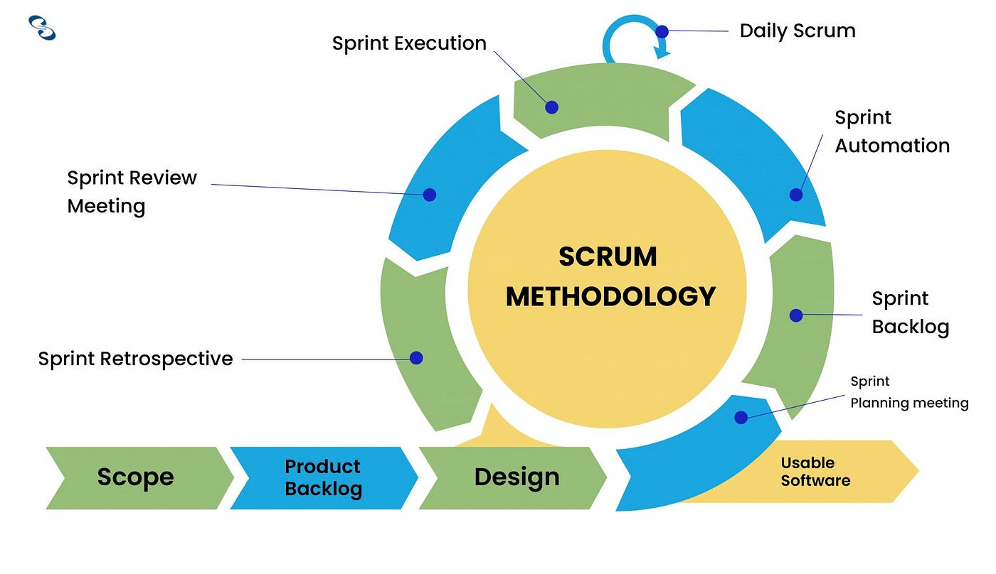

Figure 1: Scrum Methodology

CHAPTER TWO

LITERATURE REVIEW

2.1 Introduction
There is a need to understand the importance of smart leak prevention systems on the economy where they are implemented, the kinds of devices needed to make the system work, and ways of improving the system's efficiency to make them better than the existing water systems. Thus, the following literature reviews reveal some gages in research connected to smart leak prevention systems.

2.2. Global Perspective
The global perspective focuses on universal technologies, challenges, and innovations in water management and leak prevention systems.
    - Smart Leak Prevention Systems and IoT Integration
Globally, smart water management systems have evolved through the integration of loT sensors, cloud computing, and real-time monitoring techniques. The adoption of lot devices and cloud-based monitoring for water quality and leak detection is now a global trend. Research like that from Bhatt and Patoliya highlights the need for inexpensive, cloud-connected sensor networks capable of real-time data collection and transmission, making it a key global solution for water monitoring.
- Real-Time Data Analytics for Leak Detection
Mutikanga et al. (2013) provide a real-time sensing and analytics framework for improving leak detection through hydraulic and water quality parameters. This global approach demonstrates how advanced data analytics can optimize water system operations and prevent leaks by detecting anomalies early.
- Advanced Leak Detection Technologies
The global trend in advanced leak detection technologies includes acoustic emission, infrared thermography, and fiber optic sensing. These methods are gaining traction globally due to their precision and ability to detect leaks in various types of pipelines, whether for oil or water. This is particularly useful in regions with aging water infrastructure.
- Optimization of Sensor Deployment
Yang and Wang (2023) present sensor optimization methodologies like detection coverage rate (DCR) and total detection sensitivity (TDS), which are globally applicable för improving leak detection accuracy. This research emphasizes a data-driven approach for sensor deployment, balancing performance with budget constraints.

2.3 Regional Perspective
The regional perspective looks at how specific regions address water management challenges using tailored solutions.
- Challenges in Urban Water Distribution Networks
In developed regions, like European cities or North America, large-scale water management systems face significant challenges, such as the aging infrastructure and water wastage due to undetected leaks. The integration of lot-based leak detection systems and real-time monitoring has become a key focus to mitigate these issues.
- SCADA Systems in Water Management
The RTM-SCADA systems analyzed by Mutikanga et al. (2013) in Antalya City, Turkey represent a regional solution in regions where real-time sensing is essential. These systems monitor both water quality and hydraulic parameters, helping identify leakages and other anomalies. They have been effective in urban centers with complex water distribution systems.
- Cost Constraints in Developing Regions
In regions like sub-Saharan Africa and South Asia, the lack of infrastructure and budgetary constraints significantly affect water leak detection and management. Studies focusing on low-cost sensor networks and simple communication protocols (such as ZigBee and Raspberry Pi) have shown promise for tackling water wastage issues in these areas. This is a regional solution aimed at affordability and accessibility.

- Impact of Climate and Geography
In areas where water scarcity is a pressing issue (e.g., parts of Africa, Middle East, and South Asia), the need for efficient leak detection systems becomes even more critical. Real-time monitoring helps prevent unnecessary water loss, ensuring the sustainability of limited water resources.

2.4 Local Perspective
The local perspective focuses on specific town, cities, or countries that face unique challenges and solutions in water leak detection
- Local Sensor Network Deployment
Locally, in cities or specific districts, sensor placement and network optimization are crucial. For example, local deployments of pH, flow, and pressure sensors in water distribution systems are becoming increasingly common. The use of ZigBee protocol for communication (as discussed by Bhatt and Patoliya) is being explored in regions with local water management challenges.
- Community Engagement and Information Distribution
In local settings, community engagement plays a key role in ensuring proper information distribution for leak detection and water quality monitoring. Bhatt and Patoliya (2016) highlight the role of local communities in distributing information and ensuring the effectiveness of smart water systems at the grassroots level.
- Local Government Initiatives
Local governments in various regions are adopting policies to address water leakage, with a focus on integrating cloud-based data systems to monitor water usage. These initiatives allow municipalities to address localized challenges like aging pipelines, high leakage rates, and the lack of infrastructure.
- Real-World Application of Leak Detection
On a local level, smaller pilot projects have been implemented in cities where water loss is a significant problem. For example, pressure sensors can be strategically placed based on local needs and hydraulic simulations, as shown by Liu et al. (2021), which can optimize the detection of leaks in a specific water network.

2.5 Conclusion: Project on Water Management Leak Prevention System
The Water Management Leak Prevention System aims to address global, regional, and local challenges related to water distribution and leakage. The literature highlights the diverse approaches to leak detection and management, from loT-based systems and real-time analytics to sensor optimization and community engagement. These insights have been instrumental in shaping the proposed system's design.
- Global Strategies like cloud-connected loT devices, real-time data analytics, and advanced leak detection technologies will provide the backbone for a scalable, efficient leak detection system.
- Regional Solutions emphasize cost-effective, region-specific technologies, especially in areas facing budgetary constraints and aging infrastructure. The optimization of sensor deployment and detection strategies tailored to each region's specific needs is critical.
- Local Application will focus on real-world pilot deployments, working closely with local communities and stakeholders to ensure adoption and continued effectiveness of the system. Additionally, sensor networks, data compression techniques, and hydraulic transient analysis will be incorporated for real-time monitoring and accurate leak detection.

CHAPTER THREE

SYSTEM ANALYSIS AND DESIGN

3.1 Introduction
This chapter presents the system analysis and design process for the FlowSmart Leak Detection System, outlining the structured approach used to develop an efficient and scalable solution for water leak detection and prevention. It begins by introducing the systems development methodology, which guides the project's framework. A feasibility study evaluates the system's practicality by assessing economic, technical, and operational factors. The requirements elicitation process details the data collection methods used to gather insights from stakeholders, such as facility managers and utility providers, through surveys and interviews. These findings shape the system’s design, ensuring alignment with user needs. The chapter further discusses data analysis, system specification, and modelling, utilizing techniques like Data Flow Diagrams (DFDs), sequence diagrams, and system architecture design to define the system’s functionality. By following this structured approach, the FlowSmart Leak Detection System will provide an effective and sustainable solution for minimizing water wastage, optimizing resource management, and reducing operational costs.

3.2 System Development Methodology
The development of the Water Detection System follows the Scrum framework, an agile methodology known for its iterative, flexible, and fast-paced approach to software development. Scrum divides the project into manageable, time-boxed segments called sprints, typically lasting 2-4 weeks, where specific features are developed and tested. Each sprint enables the delivery of functional modules, ensuring that components such as sensor data processing, leak detection algorithms, and alerting systems are continuously integrated and refined. The cross-functional team works collaboratively, with developers, testers, and business stakeholders ensuring the system meets both user needs and business requirements. The approach fosters constant feedback loops, enabling the team to make quick adjustments and ensure that the system evolves with high quality and minimal risk.


Figure 2: Scrum methodology

The development process follows the Scrum framework, which consists of Sprints—short, time-boxed iterations that deliver functional software increments. The Scrum process included:
- Product Backlog Creation: The Product Owner defined and prioritized user requirements as backlog items.
- Sprint Planning: The Scrum Team selected high-priority backlog items to be implemented in the Sprint.
- Sprint Execution (Development & Testing): The team worked on transforming user stories into working software artefacts.
- Daily Scrum Meetings: The team held brief stand-ups to track progress, address blockers, and align on goals.
- Sprint Review: At the end of the Sprint, the working product increment was demonstrated to stakeholders for feedback.
- Sprint Retrospective: The team reflected on the Sprint process, identifying areas for improvement in the next cycle.
Each Sprint results in a functional software increment that will be integrated into the larger system. Stakeholder feedback will continuously be gathered and incorporated into the Product Backlog for future Sprints, ensuring that the evolving system aligned with user expectations and requirements.

3.3 Feasibility Study
A feasibility study was conducted to determine the viability of the Flow-Smart IoT Leak Prevention System in terms of economic, technical, operational, and legal aspects.

3.3.1 Technical Feasibility
The FlowSmart Leak Prevention System showcases high technical feasibility, utilizing the integration of Internet of Things (IoT) and advanced data analytics. The system's architecture is designed to align with current technological trends, ensuring compatibility with existing infrastructures.

3.3.2 Operational Feasibility
From an operational standpoint, FlowSmart is highly feasible. It is designed to be seamlessly integrated into existing water management systems, requiring minimal disruption to current operations. The user-friendly interface and automated alert system ensure ease of use for operators, making the system smooth and efficient to operate. The system’s ability to provide real-time data and predictive analytics enhances operational effectiveness, enabling proactive maintenance and decision making.

3.3.3 Economic Feasibility
The economic feasibility of the FlowSmart Leak Detection System is assessed by analyzing the costs involved in development, deployment, and maintenance, as well as the expected financial benefits. The primary goal is to ensure that the system delivers a cost-effective solution for water management while minimizing financial burdens on stakeholders.
The initial investment includes expenses for software development, hardware acquisition, and system deployment. Ongoing costs cover system maintenance, cloud storage, and data analytics. The benefits of implementing the system include cost savings from early leak detection, reduced water wastage, and lower operational expenses. By integrating predictive analytics and real-time monitoring, the system is expected to significantly reduce water-related financial losses, making it a financially viable solution.

Initial Costs (Reduced):
- Software Development: KSH 900,000
- Sensor Hardware & Infrastructure: KSH 200,000
- System Deployment & Training: KSH 100,000
- Total Initial Cost: KSH 1,200,000

Ongoing Annual Costs:
- System Maintenance & Support: KSH 52,000
- Cloud Storage & Data Processing: KSH 65,000
- Total Annual Ongoing Cost: KSH 117,000

Annual Savings & Benefits:
- Reduced Water Losses: Predictive leak detection is estimated to reduce water losses by 30%, saving approximately KSH 1,040,000 per year in utility costs.
- Lower Maintenance Costs: Automated monitoring reduces the need for manual inspections, saving an estimated KSH 455,000 annually.
- Operational Efficiency: Automation of data collection and analysis streamlines processes, saving approximately 150 hours per year at KSH 3,250 per hour, totaling KSH 487,500 annually.
- Environmental and Compliance Benefits: Improved water conservation efforts can help organizations avoid fines and penalties associated with excessive water usage, estimated at KSH 260,000 annually.
- Total Annual Savings: KSH 2,242,500

ROI Calculation (Over 3 Years):
- Total Benefits Over 3 Years: KSH 2,242,500 × 3 = KSH 6,727,500
- Total Costs Over 3 Years: KSH 1,200,000 (initial) + (KSH 117,000 × 3) = KSH 1,551,000
- Net Benefit: KSH 6,727,500 - KSH 1,551,000 = KSH 5,176,500
- ROI (%) = (5,176,500 / 1,551,000) × 100 = 333.76%
With an ROI of 333.76% over three years, the FlowSmart Leak Detection System proves to be an economically viable investment. The lower initial costs further enhance its affordability, ensuring financial sustainability while effectively addressing water management challenges.

3.3.4 Legal and Ethical Feasibility
- The system is designed with a strong emphasis on IoT security standards to ensure the privacy and integrity of data. It implements robust user authentication mechanisms, safeguarding against unauthorized access and ensuring that only authorized personnel can interact with sensitive information. Furthermore, the system complies with relevant environmental regulations, ensuring that water usage is monitored and managed responsibly, helping organizations meet their sustainability goals while maintaining compliance with industry standards. This holistic approach prioritizes both security and environmental responsibility, making the system reliable and trustworthy for users and stakeholders.

3.4 Requirements Elicitation
Requirements elicitation is the process of gathering information from stakeholders to define the features and functionality of the FlowSmart Leak Detection System. The goal is to understand the challenges faced by users, such as facility managers and utility providers, and ensure the system effectively addresses water leakage issues. Various data collection tools, including interviews, surveys, and observations, will be used to obtain qualitative and quantitative insights into existing water management challenges. Interviews will be conducted with key stakeholders to understand their pain points, operational constraints, and desired system functionalities. Surveys will gather data on water leakage frequency, current detection methods, and user expectations. Observations of water monitoring processes will provide firsthand insights into inefficiencies and areas for improvement. This structured approach ensures that the FlowSmart Leak Detection System is designed to meet user needs, enhance water conservation, and optimize operational efficiency.

3.4.1 Data Collection Methods
To gather the necessary information for developing the FlowSmart Leak Detection System, a combination of interviews, surveys, and observations will be used. These tools help collect both qualitative and quantitative data, ensuring a comprehensive understanding of user needs and existing challenges in water leakage detection and management.
- Interviews: Discussions with facility managers, maintenance teams, and utility providers will help identify key issues related to water leakage monitoring, response times, and the limitations of current detection systems. These interviews will provide insights into operational workflows and expectations for an automated solution.
- Questionnaires: Structured questionnaires will be distributed to facility managers and utility service providers to collect data on water loss incidents, existing detection technologies, and preferred features for the new system. The responses will help quantify the impact of leaks and define user priorities.
- Observations: Direct observation of water monitoring processes, including manual leak detection and repair workflows, will be conducted. This will help identify inefficiencies, assess how leaks are currently managed, and determine how automation can improve response times and reduce water wastage.

3.4.2 Sampling Techniques
To ensure that the data collected accurately reflects the needs of stakeholders, a combination of purposive sampling and random sampling techniques was used. This approach ensured that insights were gathered from the right individuals while also capturing diverse perspectives from different users.
For interviews, purposive sampling was applied, targeting individuals directly involved in water management, leak detection, and maintenance. These professionals were selected because they have firsthand experience dealing with water leaks, monitoring systems, and response strategies. Their input was crucial in identifying system limitations and areas for improvement.
For surveys, random sampling was used to reach a broad range of facility managers, property owners, and utility service providers. This ensured that responses came from users with varying experiences, including those who have faced recurring water leakage issues and those who have not but could benefit from a proactive detection system. By using this approach, the study captured a wide range of perspectives, making the findings more comprehensive and applicable.

3.4.3 Sample Size Determination
The sample size was determined to balance meaningful data collection with study feasibility. A total of 10 facility managers and maintenance professionals participated in interviews, providing insights into the operational challenges of leak detection and water management. Additionally, over 50 respondents from different backgrounds completed the survey, offering perspectives on water conservation, system usability, and potential adoption barriers.
This sample size was considered sufficient to identify key trends and user needs while keeping data analysis manageable. The insights gathered helped shape the system design, emphasizing features such as real-time leak alerts, predictive analytics, and automated reporting, ensuring that the FlowSmart Leak Detection System effectively addresses water leakage challenges.

3.4.4 Data Relevance
The data collected was directly aligned with the project’s objectives, ensuring that the insights gathered addressed the core challenges outlined in the problem statement. Key findings highlighted the difficulty in detecting water leaks early, the need for automated and predictive leak detection systems, and a strong demand for real-time monitoring and alert notifications. These insights were essential in defining the system’s requirements, emphasizing the need for sensor-based monitoring, predictive analytics, and automated reporting to improve water management efficiency.
By utilizing a combination of interviews, surveys, and observations, the study captured perspectives from both facility managers and water service providers. This comprehensive approach ensured that the FlowSmart Leak Detection System would effectively address water leakage issues while offering a user-friendly, data-driven solution to enhance water conservation efforts.

3.4.5 Data Analysis
This section presents the analysis of responses collected from stakeholders, including facility managers, residents, and water utility personnel, regarding the FlowSmart Leak Prevention System. The collected data is analyzed to assess the key challenges related to water leakage, existing leak detection methods, and user expectations for an automated solution. The analysis helps identify patterns in water loss, preferred notification methods, and the potential cost savings from early leak detection. These insights guide the refinement of system features, ensuring that the final solution enhances water conservation, improves maintenance efficiency, and aligns with long-term sustainability goals.
Responses
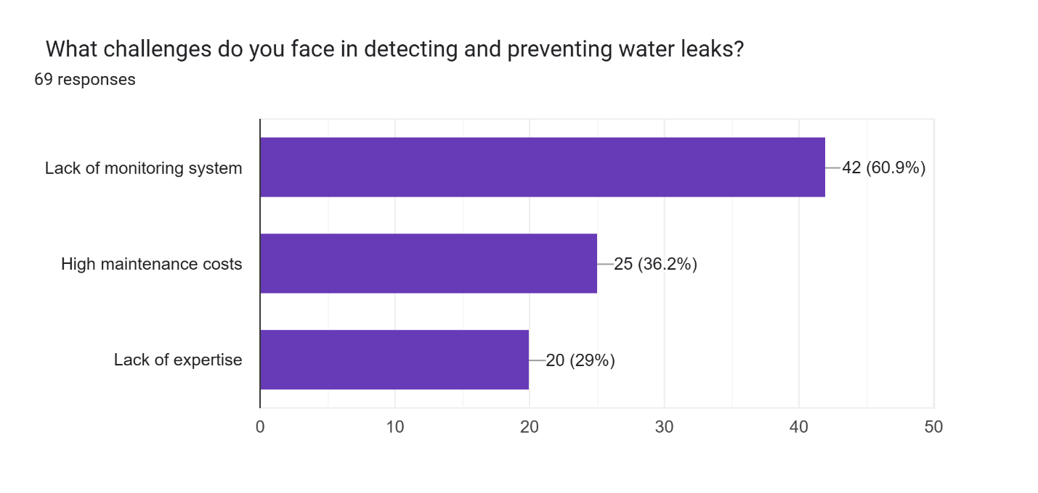

Figure 3: What challenges do you face in detecting and preventing water leaks?

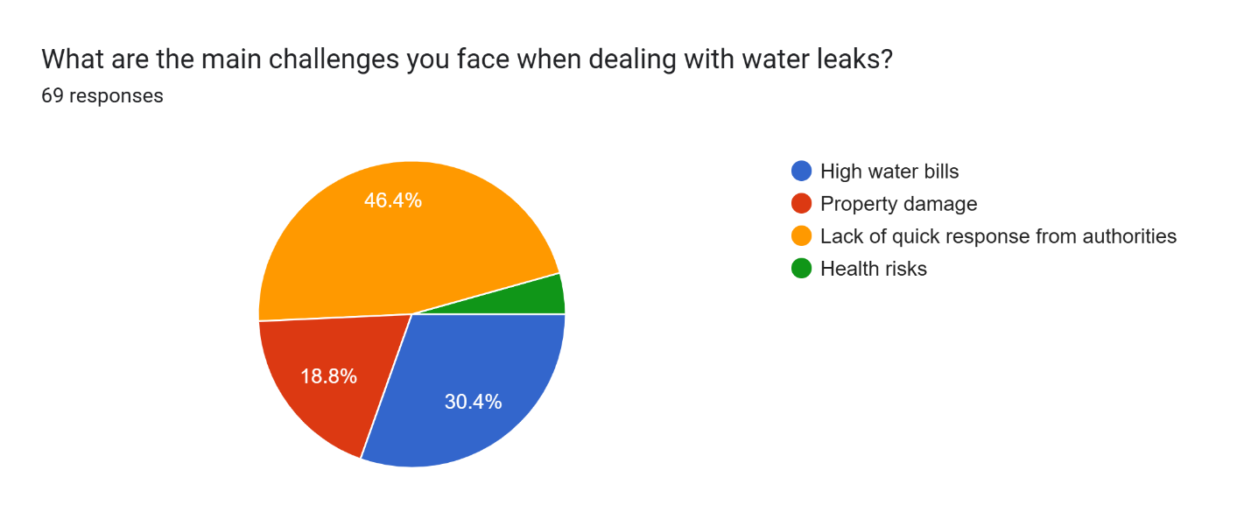

Figure 4: What are the main challenges you face when dealing with water leaks?
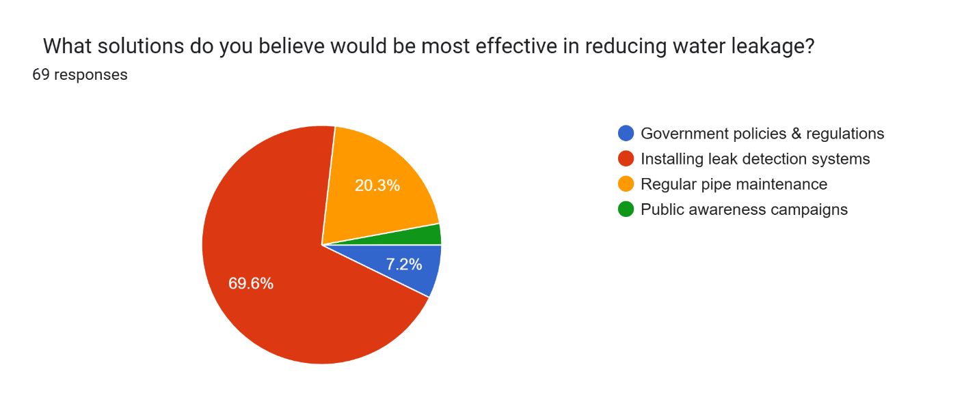

Figure 5: What solutions do you believe would be most effective in reducing water leakage

3.5 System Specification
The System Specification defines the key functional and non-functional requirements necessary for the successful development of the FlowSmart Leak Detection System. It serves as a blueprint, ensuring the system meets its intended goals of detecting leaks, minimizing water wastage, and improving operational efficiency. Functional requirements outline core features such as real-time leak detection, automated alerts, and data analytics, while non-functional requirements focus on performance, usability, and security. By clearly specifying these aspects, the system ensures reliability, efficiency, and seamless integration into existing water management frameworks.

3.5.1 Functional Requirements
1. Real-time Data Collection: The system must continuously collect data from the water distribution network using IoT sensors.
2. Data Processing and Analysis: It should be capable of processing and analyzing the collected data to detect anomalies indicating potential leaks.
3. Predictive Analytics: The system must utilize data analytics algorithms to predict potential leakages based on historical and real-time data.
4. User Interface: Provision of an intuitive user interface for monitoring and managing the system, accessible through web and mobile platforms.
5. Alert System: An efficient alert mechanism to notify the relevant authorities or personnel about detected leaks.

3.5.2 Non-Functional Requirements
1. Scalability: The system should be scalable to accommodate expansion in sensor networks and data volume.
2. Reliability: High reliability and uptime, ensuring continuous monitoring without significant disruptions. 3. Security: Robust security measures to protect sensitive data and system integrity.
4. User Accessibility: Ease of use for various stakeholders, including technical and nontechnical users.
5. Performance: Efficient performance in terms of data processing speed and accuracy in leak detection.

3.6 Requirements Analysis and Modeling
This section focuses on analyzing and structuring the system requirements to identify dependencies, resolve conflicts, and organize the requirements into clear functionalities and system components. Various modeling tools such as Data Flow Diagrams (DFDs), use case diagrams, and class diagrams will be used to visually represent and clarify the system's design. By structuring the requirements effectively, the system can be developed with a clear understanding of how different components interact and contribute to the overall functionality.

3.7 Requirements Analysis
The requirements analysis phase involves breaking down gathered requirements into manageable parts to guide system design and development. This process identifies dependencies, resolves conflicts, and ensures system components align and function cohesively. Requirements are then mapped to specific functionalities, categorized into core modules such as data collection, leak detection, reporting, and user management. Techniques like functional decomposition, requirement traceability matrices, and stakeholder feedback aid in structuring the requirements into functional and non-functional categories. This approach minimizes design flaws, enhances system efficiency, and ensures alignment with user needs and expectations.

3.8 Visual Modeling Tools
Several visual modeling tools will be employed to make the system design clearer and easier to understand. These tools will help in organizing the system’s structure and in demonstrating how the components interact with each other.

3.8.1 Use Case Diagrams
A use case diagram was developed to illustrate interactions between the user, administrator and maintenance personnel.
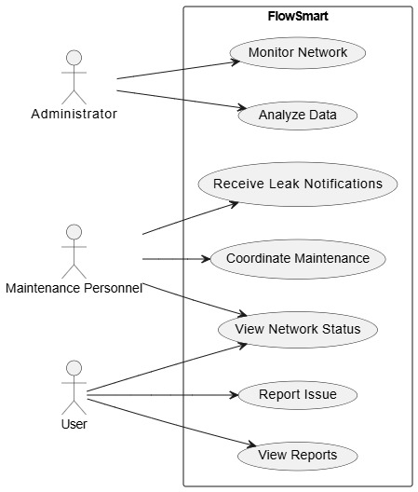

Figure 6: Use case Diagram

3.8.2 Sequence Diagram
Illustrates the dynamic flow during leak detection: IoT devices send sensor data to the LeakDetectionSystem, which processes it, checks for leaks, and alerts the dashboard—capturing interactions between components.
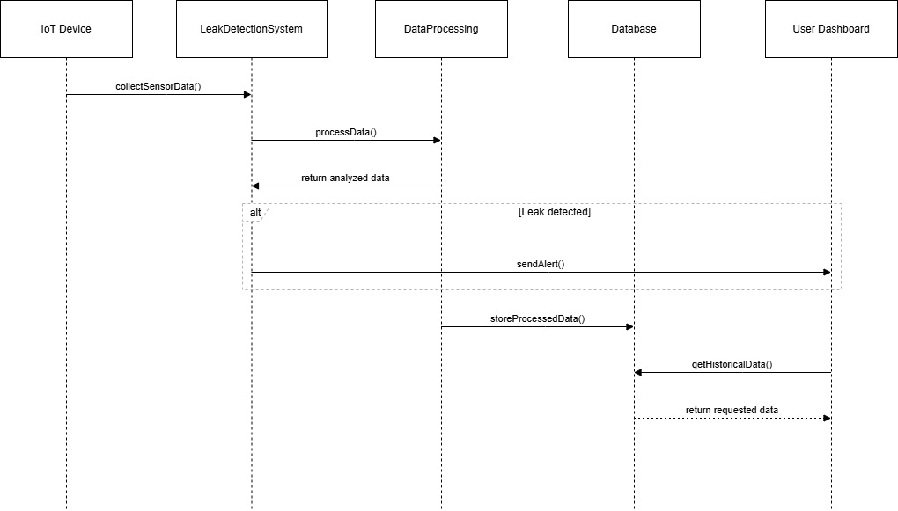

Figure 7: Sequence Diagram

3.8.3 Class Diagram
Depicts the system’s object-oriented architecture, including core classes like Leak Detection System, Data Processing, and Dashboard, with their attributes (e.g., flow Rate, pressure) and methods (e.g., detect Leak ()).
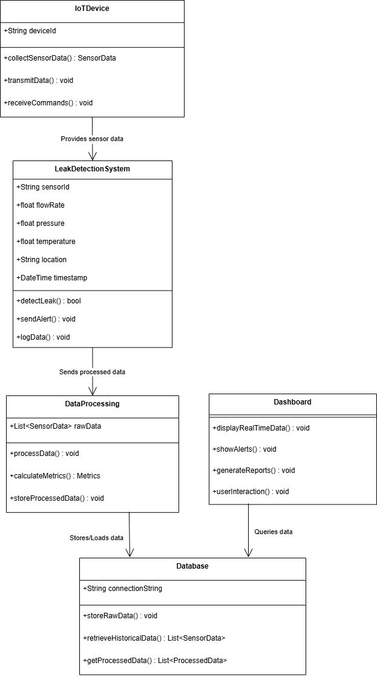

Figure 8: Class Diagram

3.8.4 ER Diagram
Represents the database structure of Flow-Smart system, showing entities like User, Device, and Sensor Data along with their relationships (e.g., a Device generates Sensor Data and triggers Alerts). It mirrors SQLite schema, with fields matching the CSV/logs in the repository.
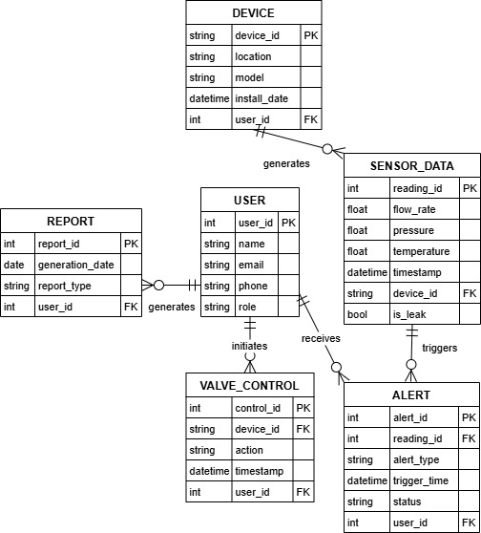

Figure 9: ER Diagram

3.8.5 Logical Design
The Logical Design phase focuses on the fundamental structure, behavior, and functionality of the Water Management Leak Prevention System. This phase defines how the various components and processes interact, ensuring the system operates efficiently and effectively.

3.8.6 System Architecture
The System Architecture for the FlowSmart Leak Detection System outlines the high-level design and key components that work together to meet both functional and non-functional requirements. The architecture is structured to ensure scalability, efficiency, and ease of maintenance. Key components include:
• User Interface (UI): Provides an interactive platform for users and administrators to monitor system status, view alerts, and access real-time leak detection data.
• Leak Detection Module: Responsible for analyzing sensor data and identifying potential leaks, using predictive algorithms and real-time monitoring to detect issues early.
• Data Management System: Handles the collection, storage, and management of data from sensors, logs, and historical records for further analysis and decision-making.
• Analytics Dashboard: Provides administrators with visual insights and reports on system performance, water usage trends, and operational efficiency, enhancing decision-making.

3.8.7 Control Flow and Process Design
The control flow defines the sequencing of tasks, from user login to dashboard presentation. Flowcharts and sequence diagrams were created to detail how users interact with the system, and how data flows between the front end, back end, and the database.

3.8.8 Design for Non-Functional Requirements
Security is implemented through hashed passwords and role-based access control. Error handling mechanisms include clear error messages for invalid login attempts, missing data, and sensor communication failures. Performance optimization techniques such as caching frequently accessed data and using efficient database queries have been integrated.

3.8.9 Database Design
The physical database design includes the creation of tables for storing user credentials, sensor data, and system settings. The database schema has been optimized for quick query responses, with indexed fields for faster retrieval of sensor data and user information.

3.8.10 User Interface Design
The User Interface (UI) design phase of the project focused on creating a seamless and intuitive experience for users of the Water Management Leak Prevention System. The interface was designed with different user roles in mind, ensuring that Administrators, Maintenance Personnel, and regular Users could easily navigate and access relevant functionalities. A clean and responsive design was achieved using Streamlit, prioritizing simplicity, consistency, and clarity. Key features like real-time sensor data, leak notifications, and role-specific dashboards were prominently displayed. The UI incorporated a professional color scheme, intuitive icons, and easy-to-read fonts to enhance usability and ensure smooth interactions, ultimately making the system both efficient and user-friendly for managing water leak prevention.
This is the sign-up page
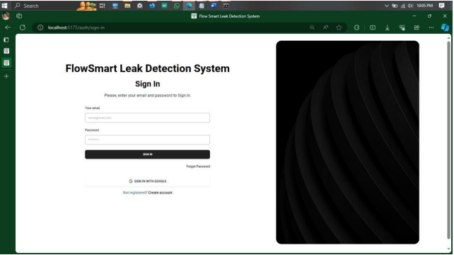

Figure 10: Sign-up page

The following is the Login page
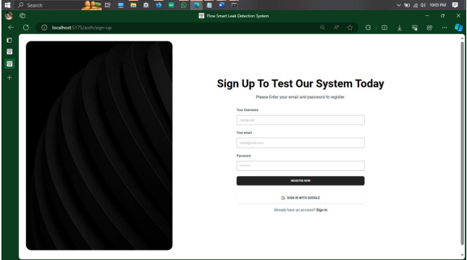

Figure 11: Login page
This image shows the analytics outcomes
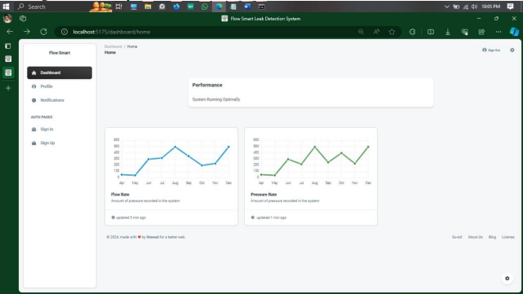

Figure 12 :Analytic outcomes

3.9 Design Phase Summary
The design phase of the FlowSmart Leak Detection System focused on creating a user-friendly and efficient platform for real-time water leak monitoring and management. The system was structured to ensure seamless data integration, incorporating IoT sensors for pressure and flow rate analysis. The frontend was developed using Streamlit, offering an intuitive interface for different user roles, including administrators, maintenance personnel, and general users. The database design leveraged SQLite, ensuring secure storage of user credentials and role-based access control. Key design elements also included an interactive dashboard displaying real-time sensor data and leak alerts. The system’s architecture prioritized scalability, modularity, and responsiveness to enhance usability and ensure accurate water leakage detection and prevention.

CHAPTER FOUR

SYSTEM IMPLEMENTATION AND TESTING, CONCLUSIONS AND RECOMMENDATIONS

4.1 Introduction
This chapter provides a detailed overview of the system implementation and testing process used for the FlowSmart Leak Detection System. It includes the environment and tools used for programming, the process of code generation, the testing strategies employed, the results of various tests, and the user guide. Finally, the chapter presents the conclusions and recommendations based on the project’s findings and limitations.

4.2 Environment and Tools
The system was implemented using a combination of backend, frontend, and middle-layer technologies to ensure a responsive and functional application. The environment and tools used for developing this system include:
- Backend Development:
  - Python: The backend logic of the system is developed using Python. Libraries such as SQLite3 for database management, Hashlib for password hashing, and Streamlit for the frontend integration were used.
  - SQLite: A lightweight database management system to store user details, reports, and leak statuses.
  - Sensor Data: A custom Python script (assumed as sensor_data.py) was used to simulate and retrieve the latest sensor data for leak detection.
- Frontend Development:
  - Streamlit: Streamlit was used for rapid web application development, enabling easy integration of Python scripts with a web interface. It allowed seamless deployment of the dashboard, where users, maintenance personnel, and administrators could interact with the system.

- Middle Layer:
  - The middle layer is represented by the integration between the database and frontend. The backend code communicates with the SQLite database to fetch, store, and update data based on user actions.

4.3 System Code Generation
The process of code generation was structured to implement the functionalities for handling users, reports, and sensor data. Key processes include:
- User Authentication and Role Management:
  - Code to handle sign-up, login, and session management was implemented to ensure secure user access. The authentication uses SHA-256 hashing for password protection.
  - The system differentiates between three roles: Administrator, Maintenance, and User, providing role-based access to different features.
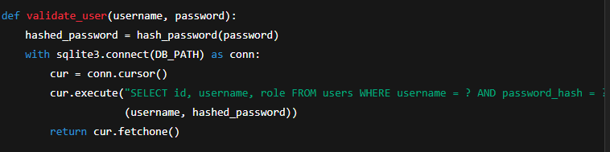
- Sensor Data Retrieval and Leak Detection:
  - Code was designed to retrieve sensor data, such as pressure and flow rate, and monitor for leaks. If a leak is detected, the system updates the status and sends notifications accordingly.
- Reporting and Leak Resolution:
  - Users can report issues, which are logged in the database, and maintenance personnel can resolve them. Reports are marked with a "Pending" or "Resolved" status.
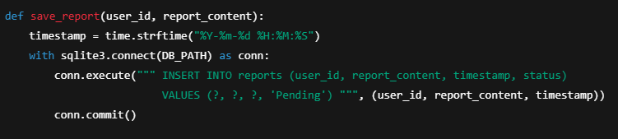

4.4 Testing
A comprehensive testing suite was developed to ensure the system works as expected across various scenarios. The testing strategies employed include:
- Unit Testing: Testing individual components like the user authentication module, sensor data retrieval, and reporting system.
- Functional Testing: Ensuring that all functionalities work together, such as user login, report submission, and leak resolution.
- Usability Testing: Aimed at ensuring the application is user-friendly. Real users were involved in testing the system's ease of use and interface intuitiveness.
- Stress Testing: Simulated high traffic and simultaneous sensor data updates to ensure the system can handle heavy usage.
- Regression Testing: Each time a change was made (e.g., adding a feature or fixing a bug), regression tests were performed to ensure that the new changes did not affect existing functionality.
- Integration Testing: Verified that the integration between the frontend (Streamlit) and the backend (SQLite and sensor data) works correctly.
Below are some snapshots of testing results:
- Login Test: Users could successfully log in and access their respective roles (Admin, Maintenance, User).
- Report Submission: Users were able to submit reports, which were saved and marked as "Pending."
- Leak Status Update: Leak statuses were updated when detected, and maintenance personnel could resolve them.
Testing the sensor data retrieval and leak detection.

4.5 User Guide
The FlowSmart Leak Detection System has a user-friendly interface for interaction. The following are the key instructions for setting up and using the software:
- System Requirements:
  - Python 3.x
  - Streamlit, SQLite3, and other dependencies (Install via pip: pip install -r requirements.txt)
- Setup:
  - Clone the project repository.
  - Install dependencies using pip install -r requirements.txt.
  - Run the system using streamlit run app.py.
- User Actions:
  - Admin: Can monitor sensor data, view and resolve leak reports, and manage user accounts.
  - Maintenance: Can monitor sensor data, log maintenance tasks, and resolve leak issues.
  - User: Can submit reports and view their issue statuses.

4.6 Conclusions
The FlowSmart Leak Detection System successfully addresses the client’s problem of monitoring and resolving water leakages in a timely manner. Key accomplishments include:
- Effective Monitoring: The system allows real-time monitoring of leak statuses, flow rates, and pressure levels.
- Role-Based Access Control: Different user roles ensure that access to system functionalities is properly managed.
- Leak Detection and Resolution: The system enables the detection of leaks and allows maintenance personnel to resolve them efficiently.
However, limitations include:
- Sensor Accuracy: The system relies on simulated sensor data, and real-world sensor integration might introduce additional challenges.
- Scalability: The system might face challenges when deployed at a larger scale, especially with numerous sensors and users.
Challenges encountered during the study include:
- Limited Tools: Certain testing tools and resources for real-time sensor integration were unavailable.
- Development Skills: While Python was effective for prototyping, integration with hardware sensors could have been smoother with more specialized tools.

4.7 Recommendations
Based on the findings from this study, the following improvements are recommended:
- Real-Time Sensor Integration: Future versions of the system should integrate with actual IoT-based sensors to provide real-time leak detection.
- Enhanced User Interface: Improving the frontend to make it even more intuitive, especially for non-technical users.
- Scalability Improvements: Address potential issues with system performance when scaling up to handle large numbers of sensors and users.

REFERENCES
J. Bhatt and J. Patoliya, "IoT Based Water Quality Monitoring System," Proc. IRFIC, 2016.
S. Kartakis, W. Yu, R. Akhavan, and J. A. McCann, "Adaptive Edge Analytics for Distributed IoT Networks," Proc. IEEE Int. Conf. Internet-of-Things Design and Implementation (IoTDI), 2016, pp. 1–10, doi: 10.1109/IoTDI.2016.00000.
G. Yang and H. Wang, "Optimal Pressure Sensor Deployment for Leak Identification in Water Distribution Networks," Sensors, vol. 23, no. 12, p. 5691, 2023, doi: 10.3390/s23125691.
BBC News, "Nairobi Water: What’s Behind Severe Shortages?," BBC News, 2019. [Online]. Available: https://www.bbc.com/news/world-africa-50253189.
M. A. Adegboye, W. K. Fung, and A. Karnik, "Recent Advances in Pipeline Monitoring and Oil Leakage Detection Technologies: Principles and Approaches," Sensors, vol. 19, no. 11, p. 2548, 2019, doi: 10.3390/s19112548.
A. Matanó et al., "Caught Between Extremes: Understanding Human-Water Interactions During Drought-To-Flood Events in the Horn of Africa," Earth’s Future, vol. 10, no. 9, 2022, Art. no. e2022EF002747, doi: 10.1029/2022EF002747.
S. Al-Haadi and A. Alahmadi, "Smart Water Leakage Detection Using Wireless Sensor Networks (WSNs)," IEEE Sensors J., vol. 21, no. 5, pp. 6120–6130, 2021, doi: 10.1109/JSEN.2021.3051234.
Y. Wu, S. Liu, and X. Wu, "A Deep Learning Approach for Water Pipeline Leakage Detection Using Acoustic Signals," J. Hydroinformatics, vol. 22, no. 3, pp. 512–526, 2020, doi: 10.2166/hydro.2020.012.
W. Shi et al., "Edge Computing: Vision and Challenges," IEEE Internet Things J., vol. 3, no. 5, pp. 637–646, 2016, doi: 10.1109/JIOT.2016.2579198.
M. Romano, Z. Kapelan, and D. Savić, "Automated Detection of Pipe Bursts and Other Events in Water Distribution Systems," J. Water Resour. Plann. Manage., vol. 140, no. 4, pp. 457–467, 2014, doi: 10.1061/(ASCE)WR.1943-5452.0000416.

S. Giri and D. Berg, "Internet of Things (IoT) for Smart Water Systems: A Review," Sensors, vol. 18, no. 8, p. 2461, 2018, doi: 10.3390/s18082461.
F. K. Shaikh and S. Zeadally, "Energy Harvesting in Wireless Sensor Networks: A Comprehensive Review," Renew. Sustain. Energy Rev., vol. 55, pp. 1041–1054, 2016, doi: 10.1016/j.rser.2015.11.010.

APPENDICES

Project Schedule

Activity | Duration (hrs) | Start Date | Actual Start Date | End Date | Actual End Date | Deliverable
Problem Identification | 24 | 2/09/2024 | 09/09/2024 | 03/10/2024 | 03/10/2024 | Identifying Problem to solve
Proposal Writing | 48 | 04/10/2024 | 04/10/2024 | 23/10/2024 | 12/12/2024 | Proposal Document
Literature Review | 48 | 24/10/2024 | 15/11/2024 | 30/10/2024 | 12/12/2024 | Literature Review Report
Proposal Presentation | 0.5 | 01/11/2024 | 13/12/2024 | 01/11/2024 | 13/12/2025 | Presentation of the final proposal
System Analysis and Design | 48 | 01/01/2025 |  | 14/01/2025 |  | System Design Document
System analysis presentation | 0.5 | 30/01/2025 |  | 30/01/2025 |  | Presentation of the workflows
Implementation | 96 | 02/02/2025 |  | 04/03/2025 |  | Writing of codes
Testing | 5 | 05/03/2025 |  | 08/03/2025 |  | Checking for errors in the system
Conclusion | 3 | 12/03/3025 |  | 14/03/2025 |  | Documentation of the whole project
System Presentation | 0.5 | 19/03/2025 |  | 19/03/2025 |  | Final Presentation

Gantt Chart

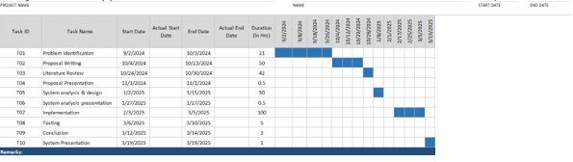

Budget

Item | Cost (ksh)
Laptop/PC | 25000
IoTsensors | 3000
Miscellaneous | 6000
TOTAL | 34000

